Collateral Web

TFS 89509 – 2016 Tax Season IRS Requirements for Real Estate Collateral

Feature Overview

The IRS has added additional requirements for form 1098 to collect information about the address of the property securing a mortgage. This information needs to be collected in the Collateral application so that it can be furnished to the IRS.

# Document Change History

|  |  |  |  |  |
| --- | --- | --- | --- | --- |
| Version | Date Changed | Description | Approved By | Date Approved |
| 1 | 08/10/16 | Document started | Rebecca McFarland | 08/10/16 |
| 2 | 9/30/2016 | Updated to include second option | Kevin Geissler |  |
|  |  |  |  |  |
|  |  |  |  |  |
|  |  |  |  |  |

Credit Products

August 10, 2016

Table of Contents

Collateral Web 1

Document Change History 1

Statement of the Problem 2

Option A (FPI Recommendation): Add fields to Locations panel on Real Estate collateral 2

TFS 89509 – 2016 Tax Season IRS Requirements for Real Estate Collateral

## Statement of the Problem

In the IRS instructions for Form 1098 in the 2016 tax year (see <https://www.irs.gov/pub/irs-pdf/i1098.pdf>), there are new data points to be collected:

* (Box 7) Address of Property Securing Mortgage
* (Box 8) Property Address (If Different form Payers’s/Borrower’s Address)
* (Box 9) Property Description (If No Address Available), e.g.

Jackson County, MO

AA-BBB-CC-DD-EE-F-GG-HHH

This information needs to be collected by the Collateral app for Real Estate collateral so that it can be provided to the IRS at tax time.

For Box 9, the IRS has specified that it should consist of the property’s jurisdiction (county and state) and then the Assessor Parcel Number(s). See this document for example formats: <http://portal.mlslistings.com/help/2011/05/26/apn-formats/>

## Option A: Add Fields to Locations Panel on Real Estate Collateral

We will now have a few items on the Locations panel on Real Estate collateral that will be configured on for all associations. Some are new, and some are reused:

* **Is Property Address Same As Mailing Address (Dropdown: YES/NO)** – new, required field
* **Address 1** – existing field, only required if address is not the same and Property Description not filled out
* **Address 2** – existing field
* **City** – existing field, only required if address is not the same and Property Description not filled out
* **State** – existing field, only required if address is not the same and Property Description not filled out
* **Zip** – existing field, only required if address is not the same and Property Description not filled out
* **Property Description (text field)** – new field, only required if address is not the same and above address fields are not filled out

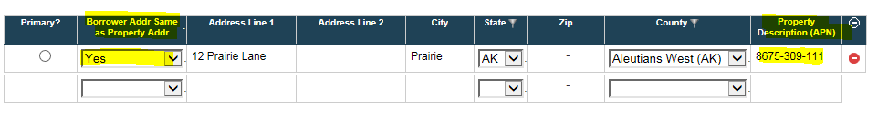

## Option B: Link Address From EmPOWER to Real Estate Collateral (FPI Recommendation)

* In the Location panel, you will have the ability to:
  + Link an existing address that is currently in EmPOWER from a dropdown menu
    - This Selection would be based on the available addresses for each member of any group that this customer is associated with
    - If you link to an existing address, you will NOT be allowed to edit this address from Collateral Web. You will need to return to CRM in EmPOWER to update the address information.
    - Auto-complete will be available in the drop down when you start typing address
    - Once you select the address, then the Address Line 1, Address Line 2, City, State and Zip data fields will be auto-populated (and read-only).
  + *OR* Create a new address (text field). This new address can be edited and updated from within Collateral Web.

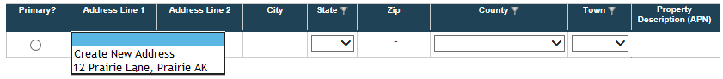

* If a linked address is selected in Collateral Web and that address is later updated in EmPOWER, you will be presented with a warning: **“The address you are changing is in use as the address of collateral.”**
* You can select **“YES”** and update the new address as the collateral address
* You can select **“No”** and the collateral address will be unchanged
  + This will be delivered in a future EmPOWER patch early in 2017
* This functionality will be for **all collateral**, regardless if the loan it is linked to belongs to an individual or business.
* We will be adding a business rule with a **soft error** **requiring** either **an** **address** **or APN** to be added for a given piece of collateral.
  + The address must have:
    - Address Line 1, City, State, Zip, OR
    - Property Description (APN), County, State

Multiple Properties Securing a Loan

If there is a scenario with a multiple properties securing a single loan, there are three ways the address can be presented:

* Three individual pieces of collateral tied to the same security document.

1. **Only one piece of collateral will be required** to have an address in the Location panel *OR*
2. **All pieces of collateral will be required** to have an address in the Location panel

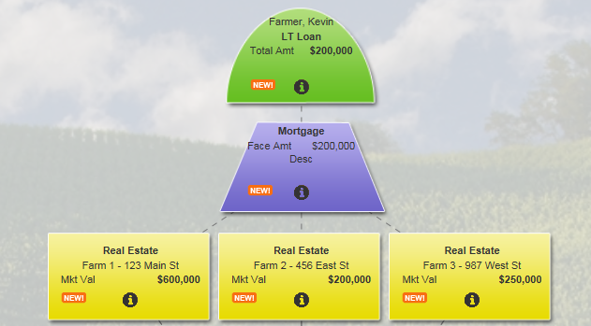

* One piece of collateral with one summary record with **multiple detail records** – one address for each piece of property
  + Each detail will display the address for each piece of property

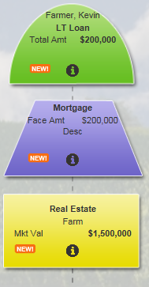

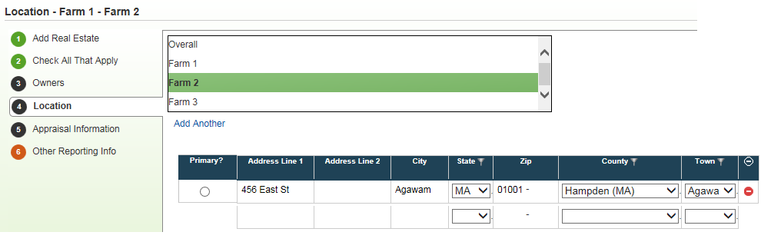

* One piece of collateral with one summary record and multiple addresses in the Location panel



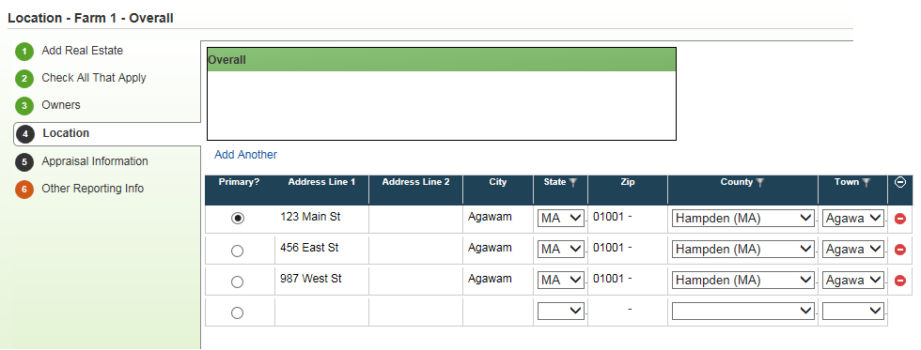

FPI will be sending a spreadsheet to the associations for customers who need 1098 forms for 2016. This is to ensure they can give accurate address information. FPI will update the addresses automatically in EmPOWER so that pre-existing loans do not need to be updated.